**Practice Exercises - Chapter: 02**

**\* Exercise 2.1:**

Write a program that prompts a user for two integers num1, num2 and print out the sum of them. 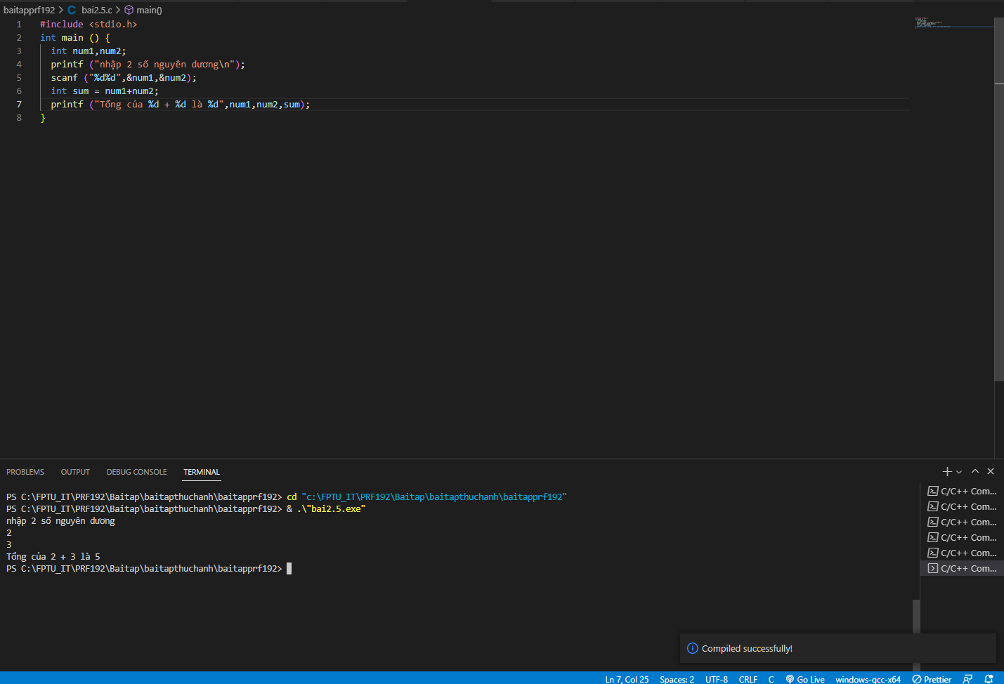

**\* Exercise 2.2:**

Restaurant Bill

Write a program that computes the tax and tip on a restaurant bill for a patron with a $88.67 meal cost. The tax is 6.75 percent of the meal cost and the tip is 20 percent of the meal cost after adding the tax. Display the total cost, tax amount, tip amount, and total bill on the screen.

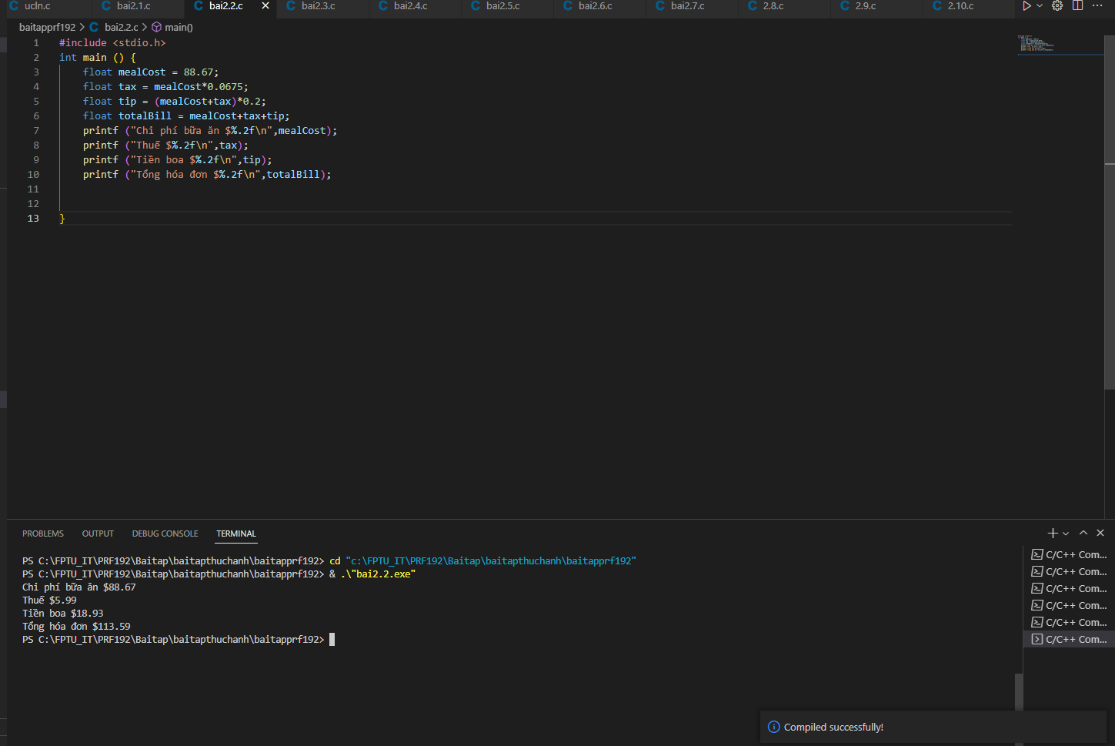

**Solution 2.2:**

**\* Exercise 2.3:**

Future Ocean Levels

During the past decade ocean levels have been rising faster than in the past, an average of approximately 3.1 millimeters per year. Write a program that computes the ocean levels expected to rise in the next 20 years if they continue rising at this rate. Display the result in both centimeters and inches measures.

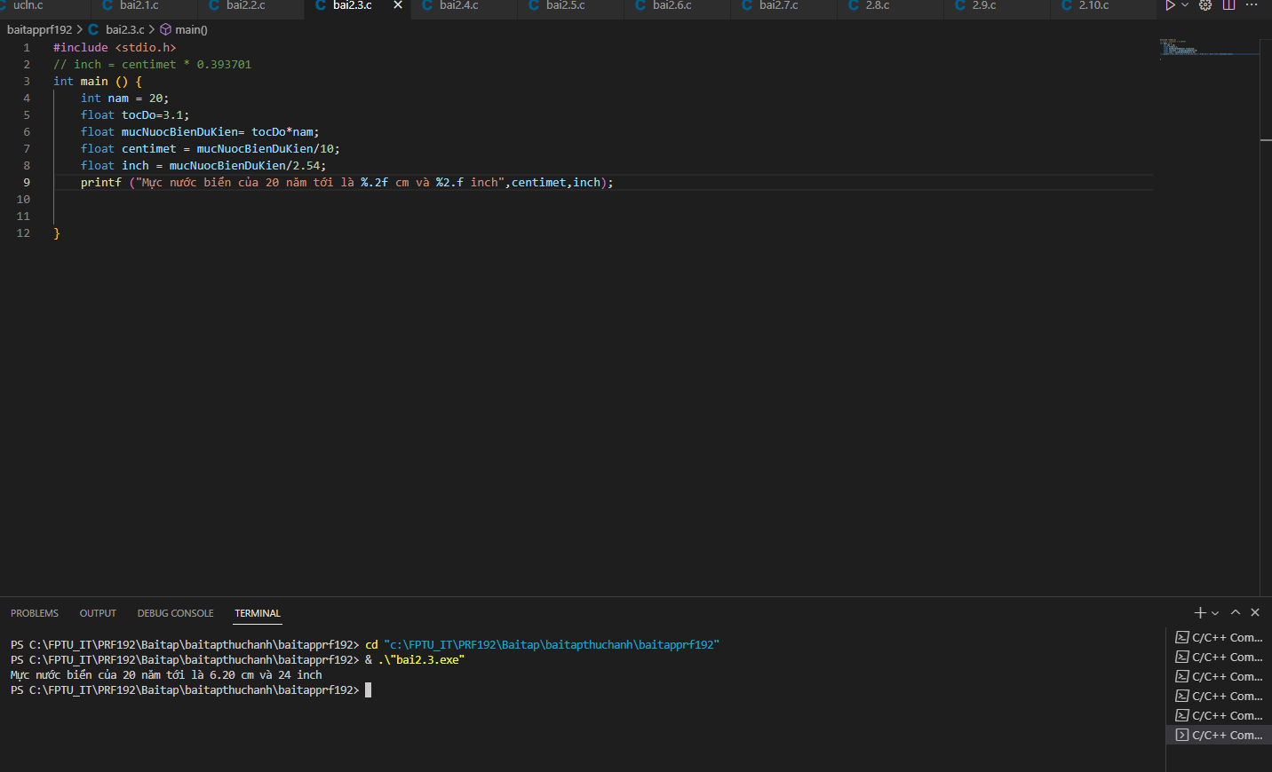

**Solution 2.3:**

**\* Exercise 2.4:**

Write a program to swap values of two variables.

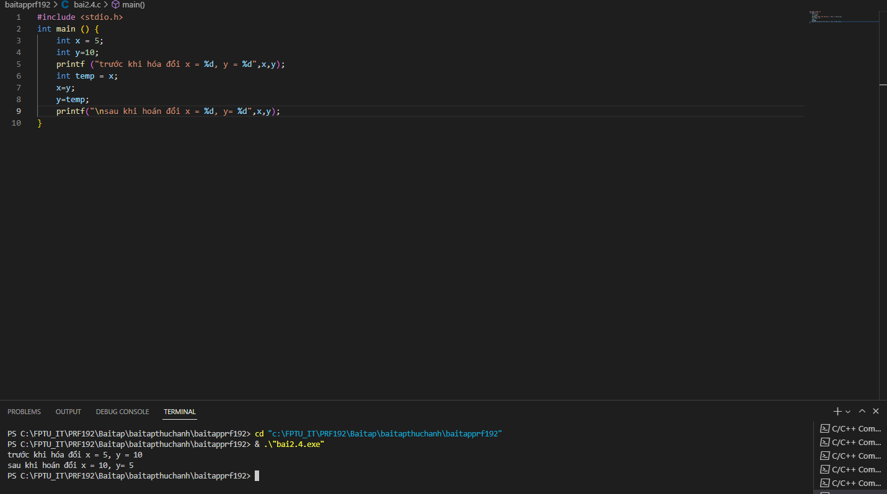

**\* Exercise 2.5:**

Write a program that prompts a user for two integers and performs all arithmetic operations (addition, subtraction, multiplication and  division).

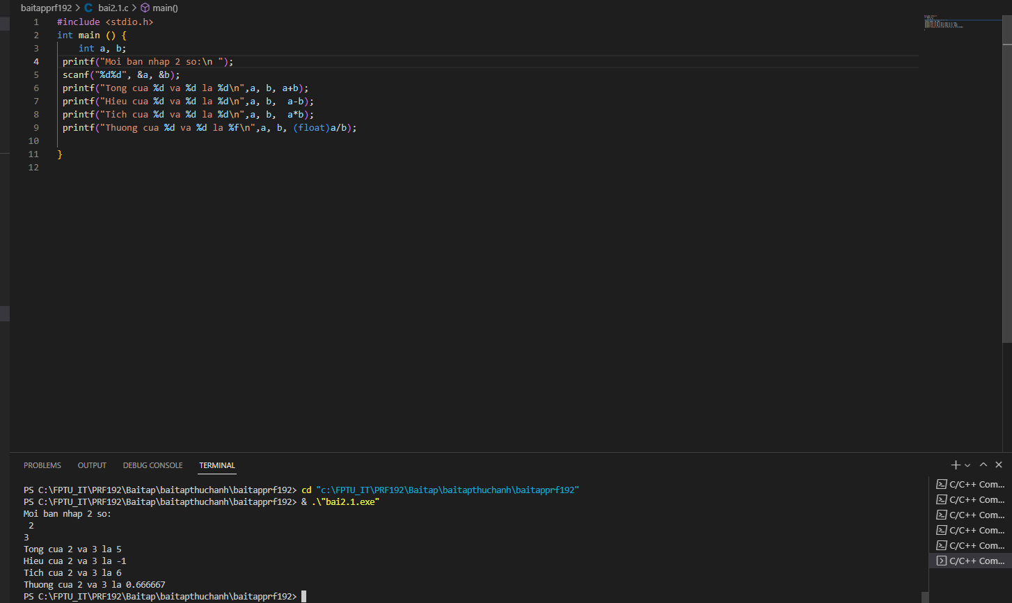

**\* Exercise 2.6:**

Write a program that prompts a user for the radius of a circle and computes the perimeter and the area of the circle.

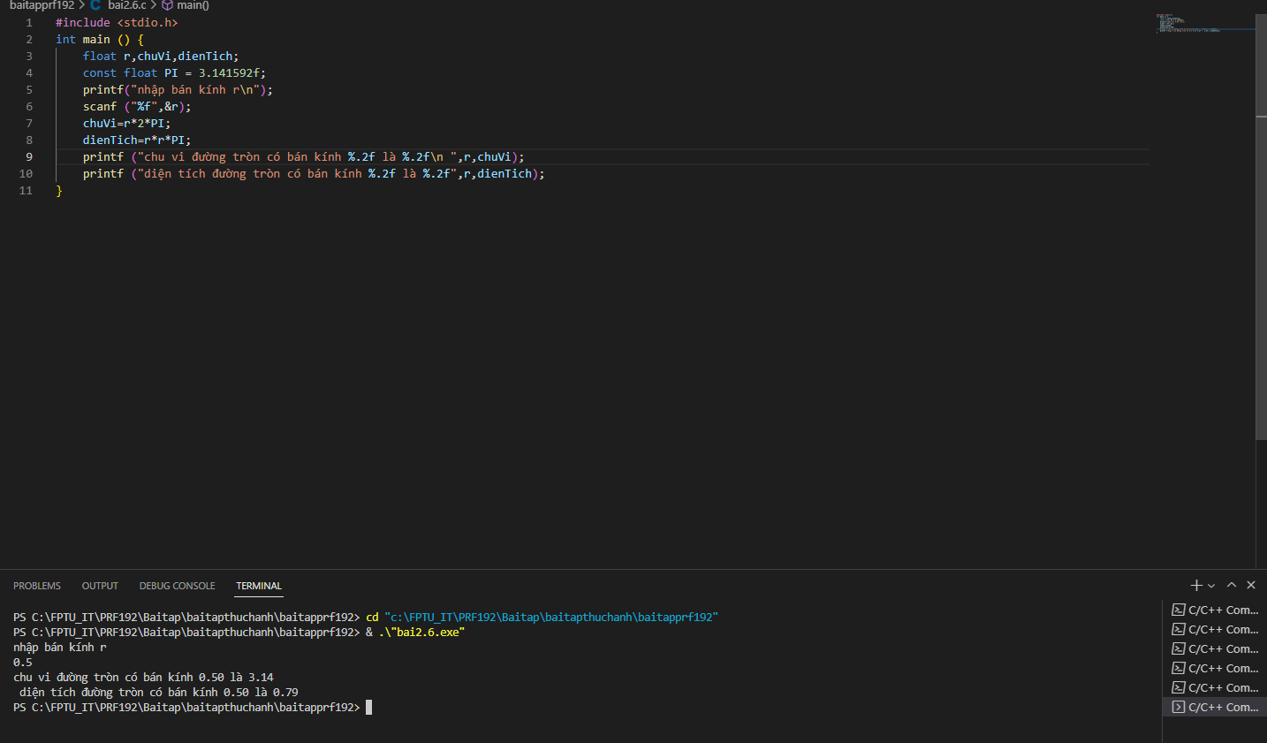

**\* Exercise 2.7:**

Write a program that prompts a user for height and width of a rectangle and then computes the perimeter and the area of the rectangle.

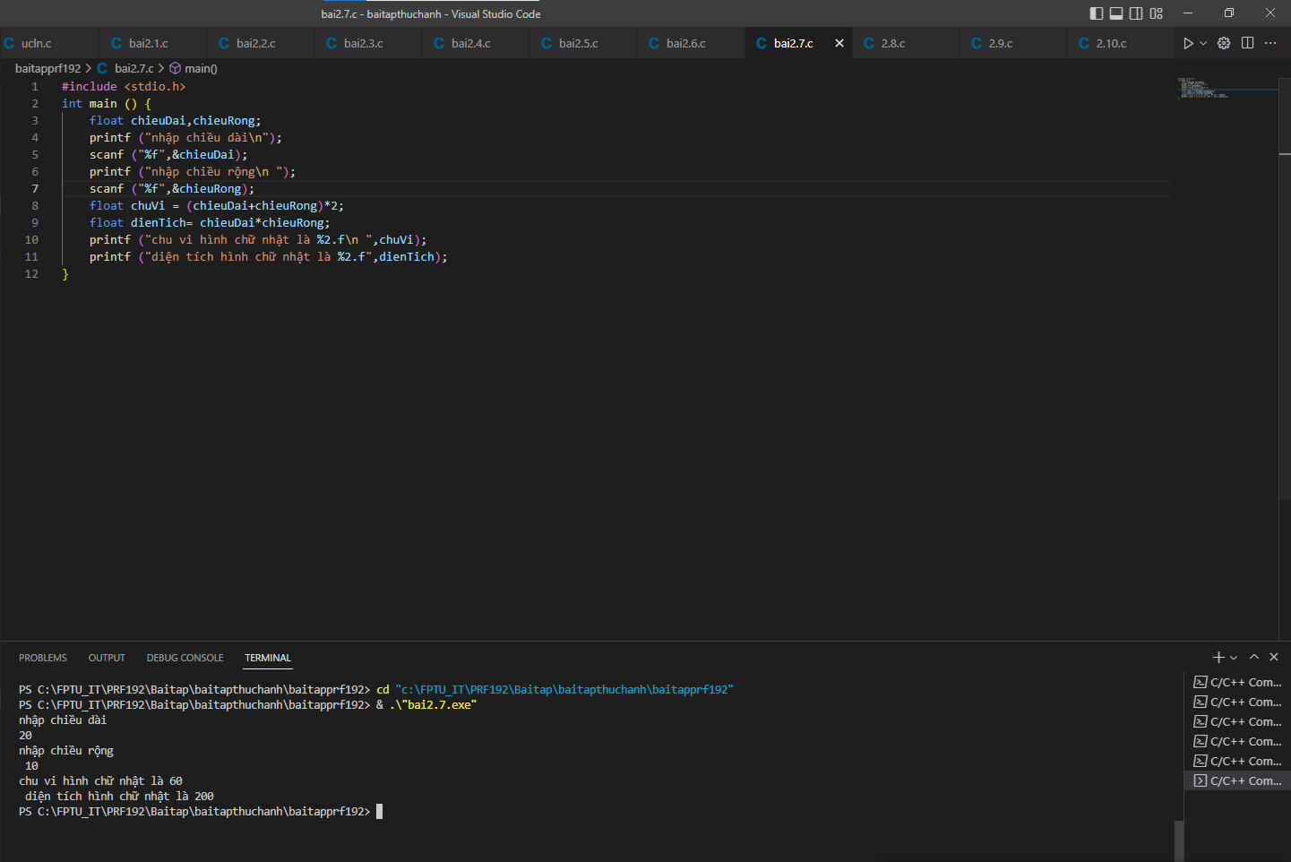

**\* Exercise 2.8:**

Write a program that prompts a user for an integer and computes the weeks and days from the entered number.

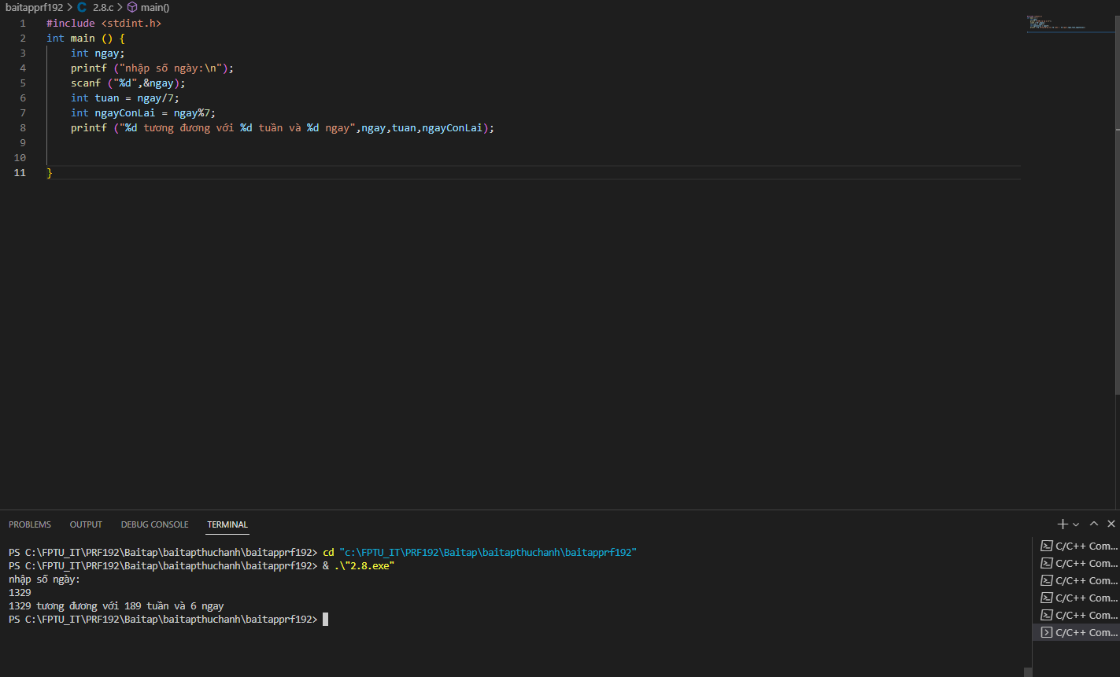

For example:  
Number of days: 1329  
Expected output  
Weeks: 189

Days: 6

**\* Exercise 2.9:**

Write a program that prompts a user for two angles of a triangle and computes the third one.

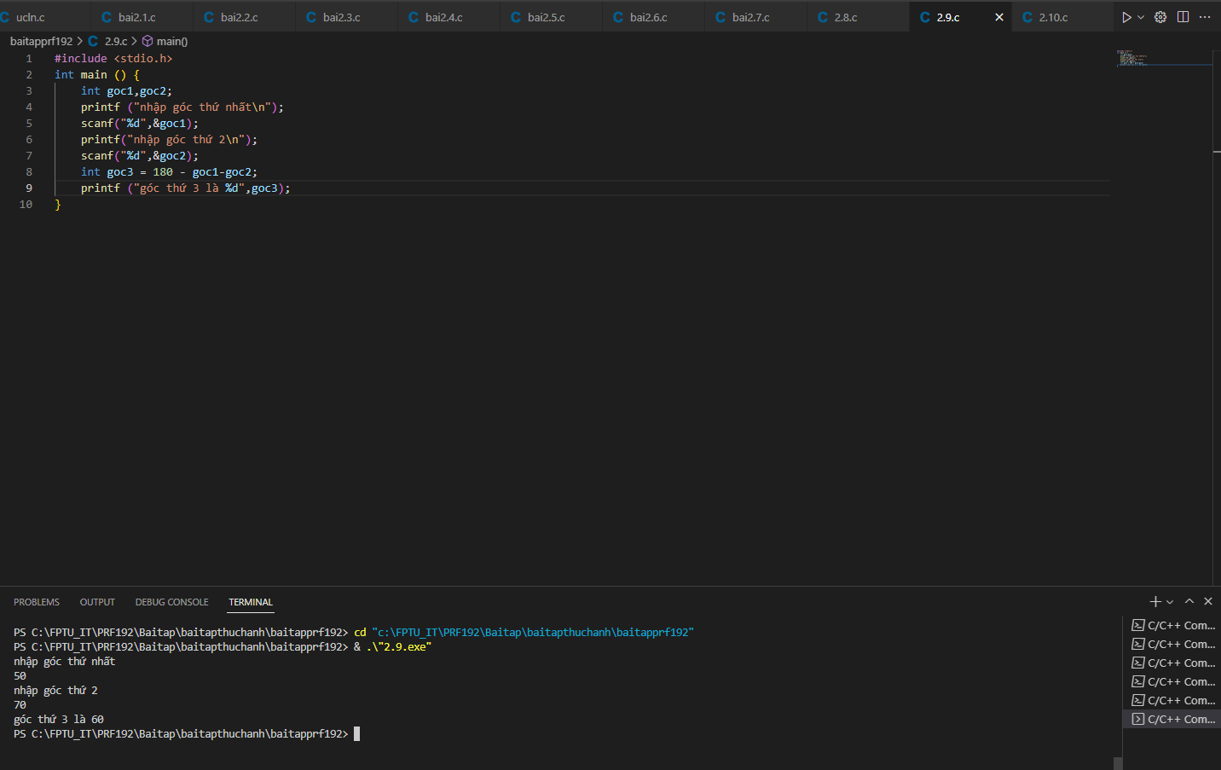

For example:

Sample Input

50 70

Sample Output

60

**\* Exercise 2.10:**

Write a program that prompts a user for hours and minutes and then calculates the number of minutes from the entered values.

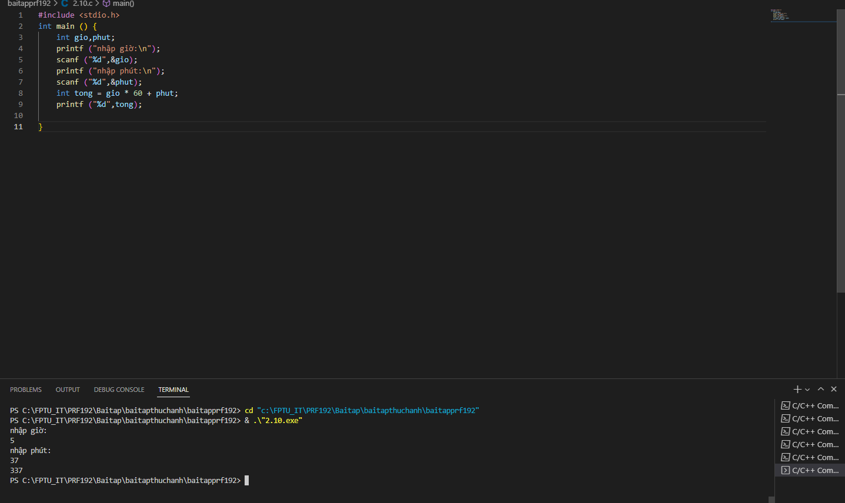

For example:

Sample Input

5 37

Sample Output

337